ICT Project Guidance

Reference Data and Code Sets Structures

Author:

Sky Sigal, Solution Architect

Version:

0.2

## Description

This document provides guidance on aspects of reference data to consider requiring and/or catering for.

## Synopsis

All systems are developed with entities that share common Reference Data, potentially developed from sector wide Data Sets.

## Contents

Description 1

Synopsis 1

Contents 2

Background 3

Risks 3

Resolution 3

Reference Data Attributes 4

ID 4

Enabled 4

From/To 4

Value 4

DisplayOrder 4

DisplayTitleReferenceKey 5

DisplayDescriptionReferenceKey 5

DisplayIconReferenceKey 5

DisplayStyle 5

Per User Customisation 5

Appendices 7

Appendix A - Document Information 7

Images 7

Tables 7

References 7

Review Distribution 7

Audience 7

Structure 7

Diagrams 7

Terms 7

## Background

Reference Data shared between system elements is common.

The Reference data may be unique to the single system, or based on externally defined and agreed Code Sets that are shared between systems.

Issues

Changes to Reference Data often require change planning to signal well in advance that the system will be made unavailable by being taken offline to make either manual or deployed changes to the system databases, sometimes the system’s logic as well.

## Risks

When a system cannot be deployed at a specific time -- and the system cannot be configured to start or stop making available options at a specified time in the future – the outcomes can be undesirable. Some examples include:

* Being in contravention of regulations and at risk of ensuing fines,
* Accepting instructions from users after a cut-off date, that then require revoking and -- if they involve a financial element -- refunding and/or issuing credit, and hopefully providing an efficient and easy way to place an replacement instruction.   
  A certain proportion of negative comments from disappointed system users is to be expected as well.

## Resolution

A mitigation of these relatively common production issues is achievable by adding more control attributes to control when information is displayed. While addressing these issues it is also relatively easy to add more attributes to control the appearance of the list and individual items within it.

The set of these attributes, used across all reference data in a system and described next, is referred to as common Reference Data Attributes.

# Common Reference Data Types

The following is a non-exhaustive list of reference data types to prompt consideration of system designs.

**Citizen Status**

: to describe whether citizens are eligible for free access to services.

**Country**

: usable to block requests from specific countries.

**Diagnostic Trace Level**

: Diagnostics, Information, Warning, Error

**Enabled**

: Categorisation to enable an entity (Person, Service, etc.)

**Gender**

: to describe Identities (or Personas) associated to a physical Person.

**Group Membership**

: Accountable, Managing, Member, Guest, Excluded

**Notification Importance**

: Low, Normal, High

**Level**

: an education categorisation (note: not automatically akin to education *Year*)

**Notification Sent Status**

: Unsent, Sent

**Notification Seen Status** : Unseen, Seen

**Qualities**

: Functional Suitability, Reliability, Performance efficiency, Operability, Security, Compatibility, Maintainability, Portability

**User Rating**

: 1-5

**Resource Membership**

: Creator, Collaborator, Reviewer, Approver, Endorser, Maintainer

**Role**

: business domain specific versions of the following logical roles: Accountable, Responsible, Supporting, Consulted, Informed, Ignored, Excluded

**Role Enrollment State**: Application to Role, Invitation Made, Pending, Rejected or Accepted, Role Established

**Sex**

: to describe physical Persons.

**Relationship**

:

* **Terms** : Synonym, Antonym, Acronym, Meaning, Pronunciation, Part…
* **Family** : Partner, Husband, Wife, Parent, Child, Sibling, Sister, Brother, Aunt, Uncle, Grandparent, Grandfather, etc.

**[Resource] Status**

: Draft, For Review, Rejected, Approved, For Release, Released, Replaced, Merged, Removed, Restored, Deleted. Note: Archive may be a separate attribute.

**Year**

: an education categorisation, unrelated to a child’s actual age.

**Workflow**

: Unprocessed/non-started, Processing, Paused, Abandoned, Processed

# Reference Data Attributes

The following catalogue of attributes should be considered when developing the shape of Reference Data items for a system.

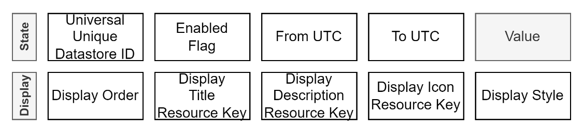

Figure : Common base Attributes of Reference Data list members

Table : Common Attributes of Reference Data entities

#### ID

: the identifier can be a local integer or universal UUID. Current best practice is to use a UUID as it provides the benefit of permitting asynchronous – including offline -- additions to a catalogue of items.

#### Enabled

: a reference item may be enabled or not, so as to quickly make unavailable an option without changing its From/To values, enabling reinstatement later without loss of this information.

#### From/To

: permits enabling reference data at a future date and time without having to time a deployment of data and/or system, to coincide with that specific date (e.g.: when a law expires and is replaced by a new one, or a term stops & starts, etc).

Note:  
This improves accessibility as the system doesn’t need taking offline to update its data, improves maintainability as the value can be changed as needed and usability as it provides users the right options at the right time.

#### Value

: the unique value of the entry is distinct from the display title of the reference item. The value may be system specific, or part of a CodeSet agreed upon between entities.

It permits referring to the same value for the item, irrespective of the display language the user chooses (which only affects the display title and description).

#### DisplayDefaultOrderPosition

: the natural display order of entries if not overridden with a per-user Most Recently Used (MRU) value specific to the current reference data group.

By convention, values are given as -1, and organised in an Ascending order.

Note:   
The use of User specific MRU’s are a relatively easy way to improve Usability of a system. See next.

#### DisplayTitleReferenceKey

: the unique key to an entry in a language specific collection of interface media (text and image) resources.

Note:  
It is convention that if the key is not found in the resource collection, then the key is displayed as is to not leave it blank.

#### DisplayDescriptionReferenceKey

: the unique key to an entry in a language specific collection of interface media (text and images) resources.

Note:  
It is convention that if the key is not found in the resource collection, then the key is displayed as is to not leave it blank.

#### DisplayIconReferenceKey

: the unique key of an optional icon within a language specific collection of interface media (text or images).

Note:  
It is convention that if the key is not found, no image is shown.

If the key is not found in the resource collection, then nothing is displayed.

#### DisplayStyle

: an optional setting to provide a means of display the single entry with a specific styling (e.g.: coloured background to indicate a selected item, etc.)

# Reference Data Titles

We recommend that all lists include the following two first settings:

1. **Undefined:**

The default value – being nobody has actually *set* this value. This value can be used during validation of data submittals, to reject the data as being incomplete.

1. **Unknown:**

*Unknown* is a valid value until another value is selected.

# Per User Customisation

The common attributes outlined above include an attribute to describe the natural order of items in a list (DisplayOrder). This order is the same for all users.

An option to improve efficiency and usability is to permit Users to persist their selection so that it is next time put at the top of the list of options.

Most Recently Used (MRU) patterns use a join table between the system User and Reference Data;

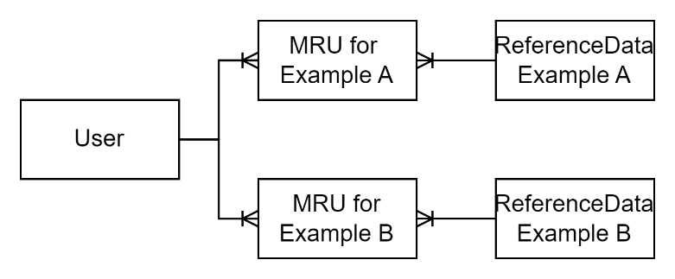

Figure : Per Category Most Recently Used (MRU) join tables.

The process is trivial in complexity but requires two operations: it has to inquire to retrieve the highest value used by the current user, add one, then either create or update an entry[1].

Note:  
It’s left up as a design decision whether the relationship is to a User, a User’s Profile, or even the Person entity associated to the User.

Appendices

Appendix A - Document Information

### Versions

* 1. Initial Draft
  2. Addition of Examples list

### Images

Figure 1: Common base Attributes of Reference Data list members 4

Figure 2: Per Category Most Recently Used (MRU) join tables. 6

### Tables

Table 1: Common Attributes of Reference Data entities 4

### References

**There are no sources in the current document.**

### Review Distribution

The document was distributed for review as below:

|  |  |
| --- | --- |
| Identity | Notes |
| Amy Orr, Data Domain Architect |  |
| Sandy Britain, Enterprise Architect |  |
|  |  |

### Audience

The document is technical in nature, but parts are expected to be read and/or validated by a non-technical audience.

### Structure

Where possible, the document structure is guided by either ISO-* standards or best practice.

### Diagrams

Diagrams are developed for a wide audience. Unless specifically for a technical audience, where the use of industry standard diagram types (ArchiMate, UML, C4), is appropriate, diagrams are developed as simple “box & line” monochrome diagrams.

### Terms

Refer to the project’s Glossary.

##### Most Recently Used (MRU)

: a relational table that is appended with the value each time a user selects a value from the list.

##### ReferenceKey

: the unique key to a resource in a resource collection.

1. Blocking the table is not recommended.